Network Capacity & Saturation Analysis
Can the existing rail system absorb the America’s Cup demand, or will it collapse?
(Diagnosis only; service-enhancement measures are covered in the Services-improvement section.)

1. Objective
The brief’s headline question is whether Naples’ transport system can absorb the extraordinary America’s Cup demand. We answer it quantitatively with a volume-to-capacity (V/C) saturation analysis of the rail lines serving the event area, comparing the as-is baseline against the event scenario, and complement it with a real road-network accessibility analysis (OSRM).

2. Study area — event zones
The demand model concentrates arrivals in 9 traffic zones. Seven came from the demand-forecast destinations; we additionally include zones 2 and 33 (Fuorigrotta / Mostra d’Oltremare), the western rail interchange (Cumana + Line 2 + Line 6) feeding the Bagnoli race course, otherwise omitted.
- West corridor (venue): zones 2, 10, 33 — Bagnoli / Fuorigrotta race & tech zone.
- Central corridor (gateway + race village): zones 1, 3, 71, 195, 216 — central waterfront and the Napoli Centrale rail gateway.
- Zone 73 (Nocera Superiore, ~30 km SE): accommodation outlier on regional rail, reported separately.

3. Data
Side | Source
Demand — tourist increment | Tourist_AGGREGATE.mtx (11.0 M trips/month region-wide)
Demand — background | TOTAL_flow.mtx − tourist = 98.8 M trips/month (as-is baseline)
Supply — line capacity | Published peak-hour, per-direction figures
Road impedance | distance_real_v2.mtx — 222×222 OSRM door-to-door driving time (min)
Region-wide the event adds +11% of trips; in the central event zones the increment reaches +23%, peaking at +50% in the Napoli Centrale gateway zone. Rail peak-hour, per-direction capacity: Metro L1 ≈ 12,000 · Metro L6 ≈ 7,200 · Metro L2 ≈ 3,600 · Cumana ≈ 1,050.

4. Method
Demand chain (per zone): monthly arrivals (matrix column-sum) ÷ 30.4 days → daily; × 8% peak-hour share → peak-hour arrivals (one direction); × 50% transit share → peak-hour rail demand.
The 8% peak-hour share is derived from the as-is data (morning peak slot 05:00–08:59 = 21.8% of daily over 4 h ≈ 5.5%/h, × within-peak factor ~1.4). Transit share is an assumption (the mobile-phone data only labels train/air) and is tested at 40/50/60%.
Saturation: V/C = peak-hour rail demand / line capacity, with LOS bands (A–C <0.60; D 0.60–0.85; E 0.85–1.0 near-capacity; F >1.0 oversaturated / “collapse”). Two calibers: corridor-level and per-line (each zone’s demand split across its serving lines in proportion to capacity).

5. Results
Per-line V/C (transit share 50%):
Line | Baseline V/C | Event V/C | LOS
Metro L1 | 0.69 | 0.84 | E — near-capacity
Metro L6 | 0.54 | 0.62 | D
Metro L2 | 0.54 | 0.62 | D
Cumana | 0.46 | 0.50 | A–C
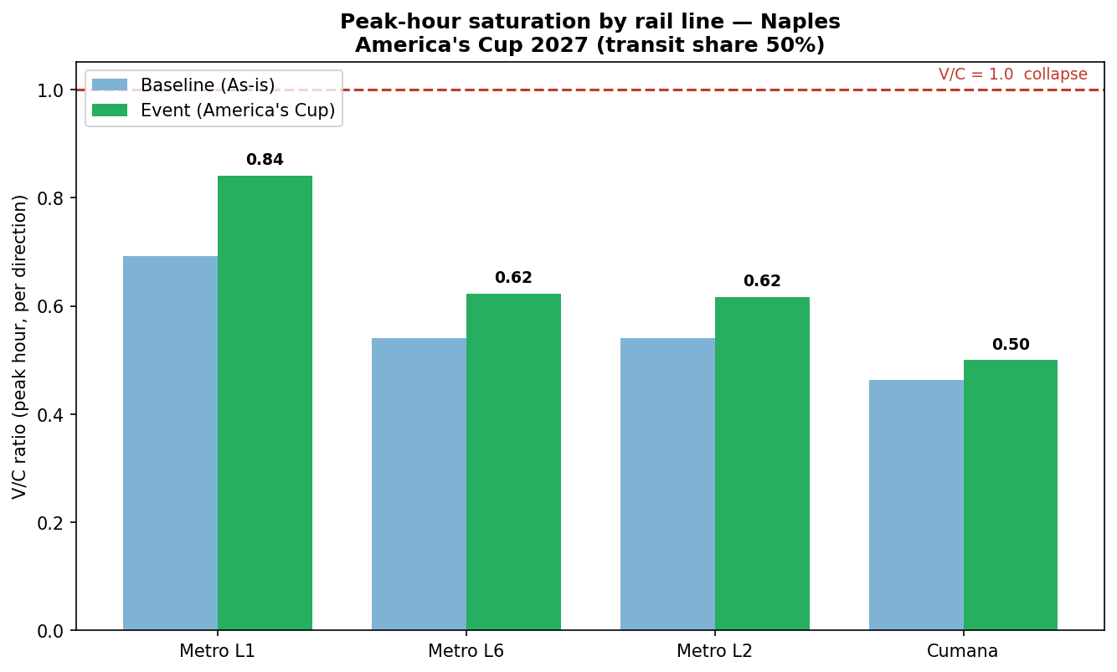
Fig. 1 — Peak-hour V/C by rail line (baseline vs event).
Sensitivity: at 40% transit share L1 sits at 0.67; at 50% it reaches 0.84; at 60% it crosses 1.01 (oversaturated). All other lines stay below 0.75. L1 is the only line at risk.
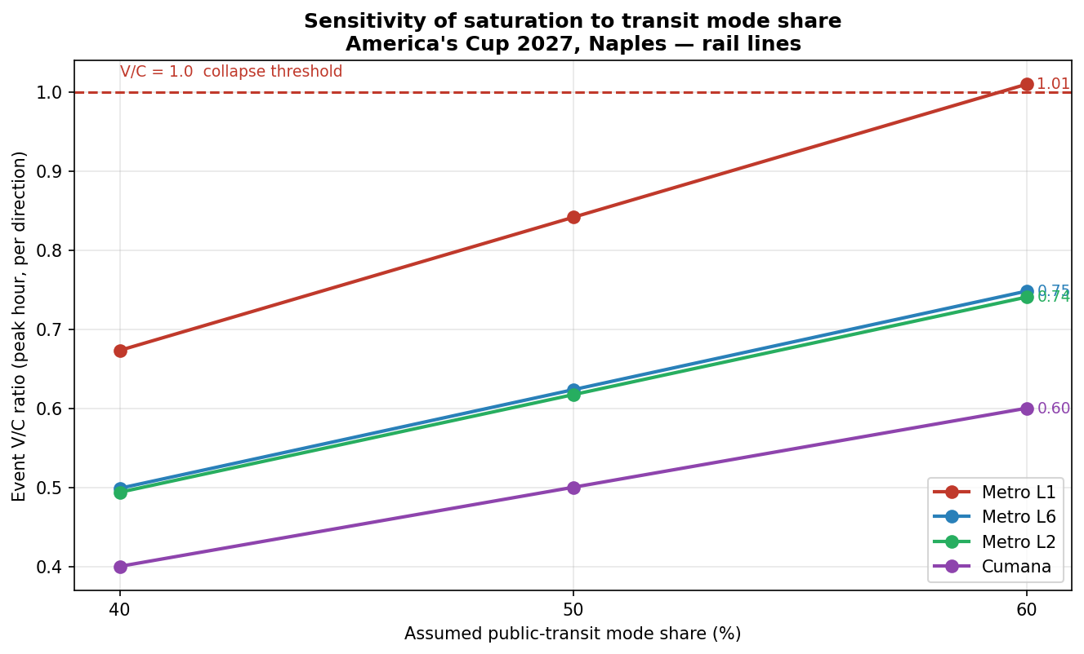
Fig. 2 — Event V/C vs assumed transit mode share. Only Line 1 crosses 1.0.
Spatial pattern: the load is highly uneven. The race venue (West) is served by three lines and keeps V/C ≈ 0.35; saturation concentrates on the central spine and the Napoli Centrale gateway.
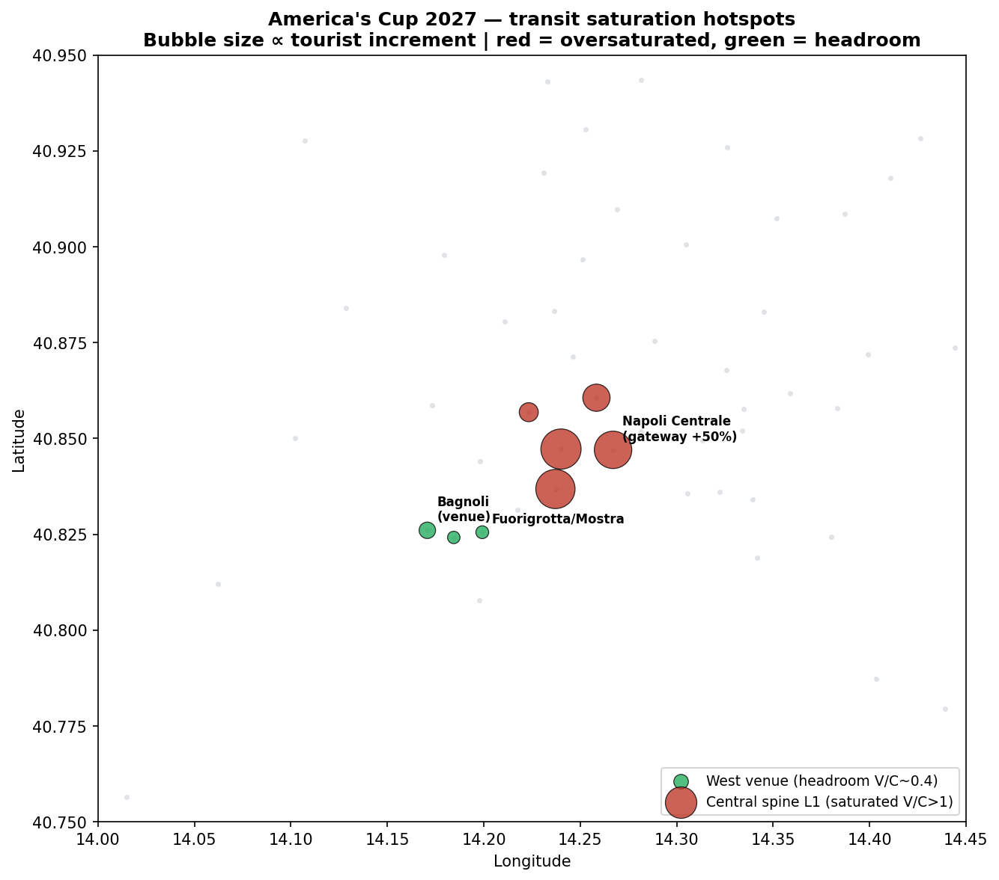
Fig. 3 — Saturation hotspots. Red = oversaturated central spine; green = headroom at the venue.
Road accessibility (OSRM): of the tourist demand originating within Campania, 73% is within a 45-minute drive of the venues (weighted-mean 37 min); but ~20% originates beyond 60 minutes (Salerno/Avellino/Cilento), depending on long road approaches and regional rail.
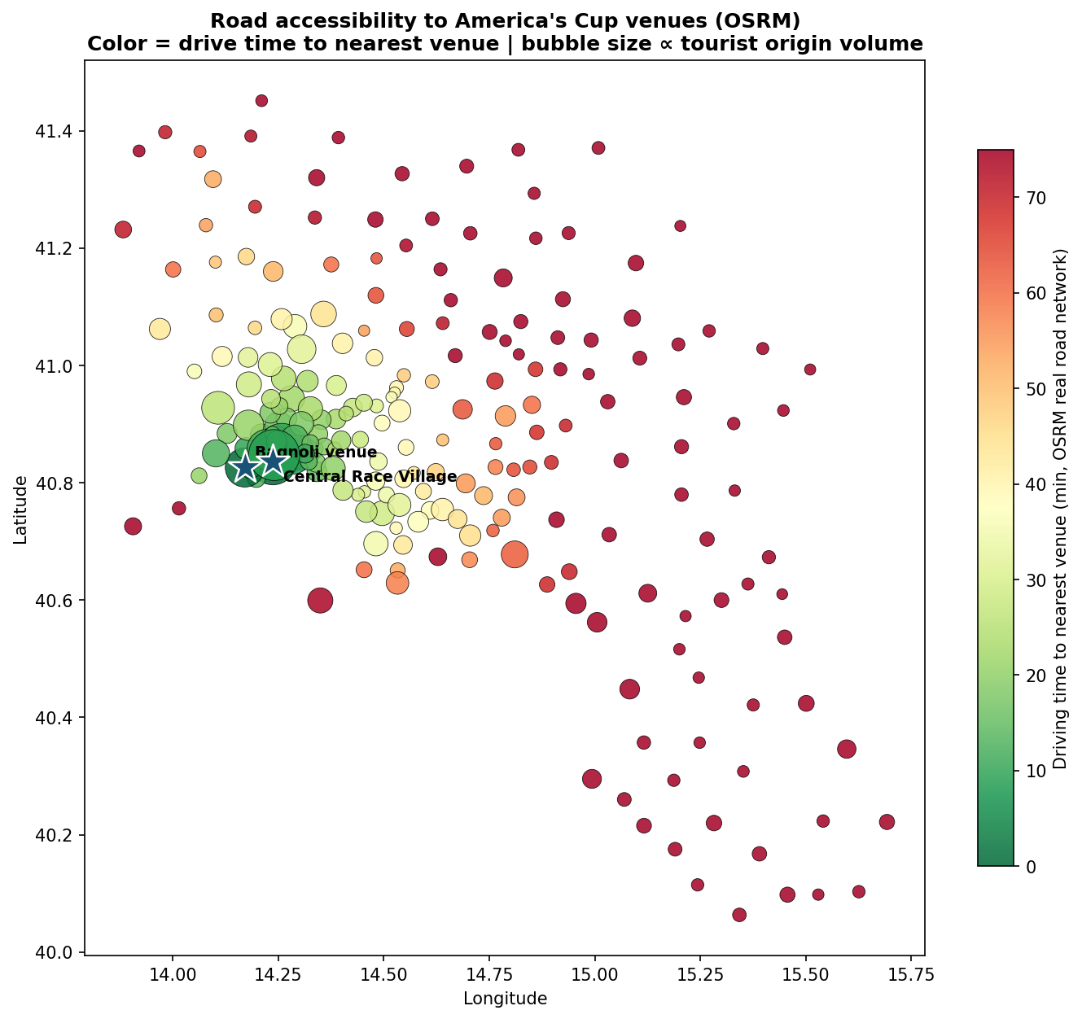
Fig. 4 — Road accessibility to venues (OSRM). Colour = drive time; bubble size = tourist origin volume.

6. Conclusion
The system does not face an aggregate capacity shortfall — total regatta-area rail capacity (~24,000 pax/h/dir) exceeds total event demand. The problem is the distribution of that capacity, not its quantity:
- Metro Line 1 is the binding constraint — the central spine serving the race village and the Napoli Centrale gateway. The event pushes it from 0.69 to 0.84, leaving no reserve, and it tips into oversaturation (>1.0) under a 60% transit share. The steepest demand growth (+50%) lands on this corridor.
- The race venue (Bagnoli/Fuorigrotta) is over-served — three lines carry only V/C ≈ 0.35–0.62.
The implication is targeted relief of the L1 / Napoli Centrale corridor (e.g. peak frequency increase, diversion via Line 6 Municipio↔Mostra), rather than network-wide expansion. The concrete service-enhancement design (shuttle-bus provision) is developed in the Services-improvement section.

